**INT305 Lab 12**

**Managing Data in Cloud Firestore**

1. Use the files from Lab 11 (TodoVue.zip)

1. In this lab, you can create a new todo, update the completed field and finally delete todo’s items.

1. Open ‘src/main.js’ and comment the “import ./assets/main.css”.

1. Open ‘src/firebase/init.js’ and add your configuration in the line with comment.

1. Open ‘src/App.vue’ and modify the code as follows:

1. Create and open ‘src/components/TodoInput.vue’ and add your code in the lines with comments.

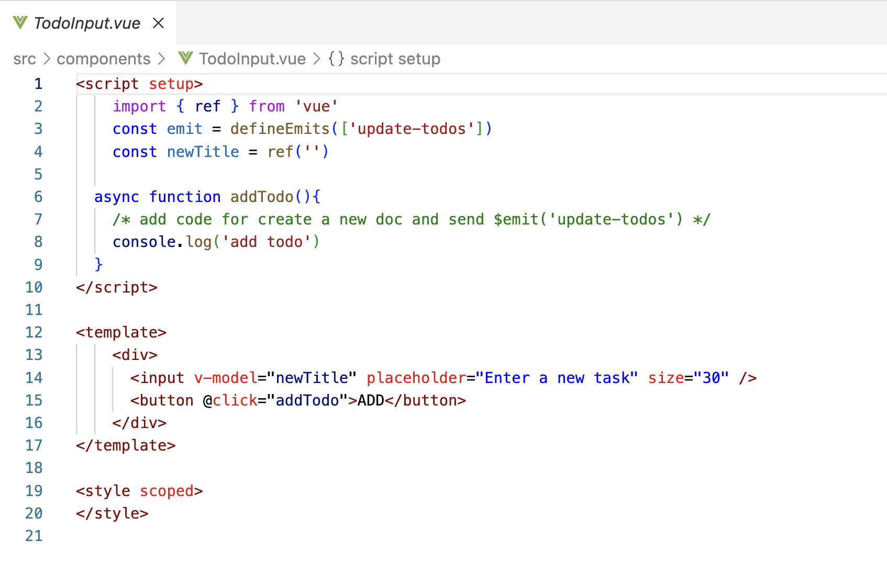

1. Create and open ‘src/components/TodoList.vue’ and add your code in the lines with comments.

1. Save your project files and run the project.

$ npm run dev

1. Before summitting your project files, remove the “node_modules” and compress the projects. Rename the zip file to xxxxxxxxxxxx.zip (xxxxxxxxxxx is your student id).